Contents
The beginning of the project 3
Project Structure and choice programming 5
CardsDeckOperation.c 5
HumanPlayer.c 5
IAPlayer.c 6
GameOperations.c 7

Introduction

During our course of IFE, we’ve been asked to program a software which aim to simulate a game of belote (specifically ‘coinche belote’). This project was to be realized in ‘C’.
I chose to do this project by myself because it was a little bit difficult for me to work in a coding team, as I just joined UTBM this semester. This was my first computer project involving software engineering, and I was (and I’m still) very exited to carry it on.

Requirements analysis and software engineering
The main design of the software is following roughly SADT method analysis (that I found easy to use after googling a little bit on the subject). I chose to not follow all the formal elements of the method but to keep only some ideas that helped me to break the project down into functions that could assembled in order to get a game of belote running.
Since I did not know how to play belote, I set myself the goal of the War (“Bataille” in French) for beginning. In the following diagrams ‘Circles’ are Data and ‘Boxes’ are functions. In addition, I decided to differentiate the input and output of the functions with different colored arrows. Arrows green corresponding to the input parameters and orange to output parameters.

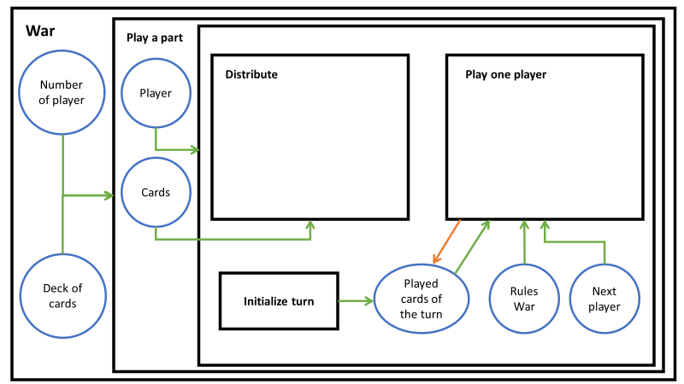
Figure 1 : Functional analysis of the game “Belote”.
Figure 1 shows the main overall view on the game ‘war’. It is composed of a main function ‘Play a game’ wich is composed of different part:

- Initialize deck and round
- Distribute cards
- Play One Player

Next step was to detail all those very high level functions.
To do so, in the functions distribute, I integrated a function that shuffle the deck of cards and another one that divide the deck of cards between the players.
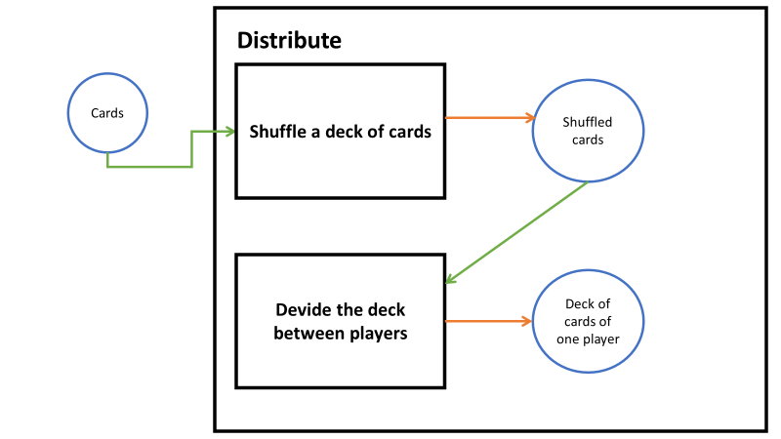
Figure 2: Detail of Distribte functions
The same process was used with the function « Play one player ».
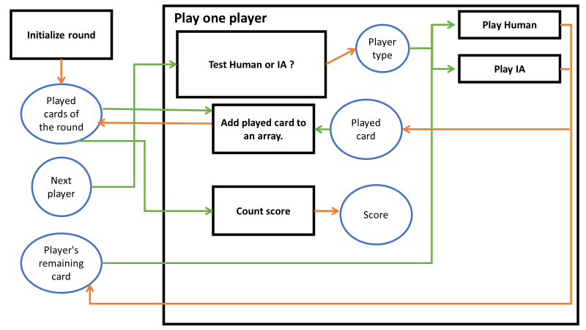
Figure 3 : Detail of the function “Play one player”.
The process was iterated several times. Some functions had to be broken down into several other functions. For example, the function "Play Human" was divided into function “Choose a card” and function “Play the card”.
Orange dashed arrows means data has been changed by the function but not returned.
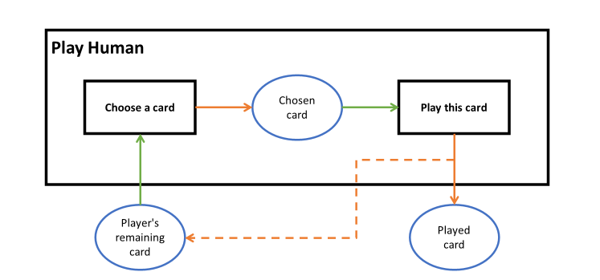
Figure 4: Detail of the function “Play Human”.
The diagrams lead to identify the functions, with input parameters and output parameters. For example:
Choose a card (Player’s remaining card) → Chosen card
Play this card (Chosen card) → Played card
Currently, it was necessary to introduce sub-functions to complete main functions.

Project Structure and choice programming
Until the end of the program, all functions were in a single file called Belote.c. It was necessary, then, to distribute functions into 3 files.

CardsDeckOperation.c
First, I created the file CardsDeckOperation.c and the header CardsDeckOperation.h to have all the functions in relation with cards in a single .c file and .h file. The .c file contains several important functions that allow the management of cards during game. It uses a struct called CARD, containing index, color and trump. Index refers to an array of cards name. It is the same for color: it contains color name. Trump is a Boolean, true if the card is a trump. The use of the CARD struct is coming from IFE cours. It allows to fluidify my code.
The deck of cards is an array. It is fills order by color and value. Then it is shuffled, using the Random function. Then, the cards are distributed in relation to the number of players through a two-dimensional array dynamically allocated. The first dimension is used for the players and the second for the number of cards.
There is also a function to resize an array after playing a card. It is called in the functions that allow a human user to play.
Finally, the two-dimensional array was unusabled. I decomposed this array into "one array per player" thanks to the "ChangeFromATwoDimensionalArrayToASingleArray" function.

HumanPlayer.c
The file HumanPlayer.c and the header HumanPlayer.h contains the functions related to human choices in the game.
The two main functions in this .c file is the contract of the human ? and the function ? which allows the user to play his round. The function Contract give the user a choice between two options: either he passes, or he bids. The other options like "capot" or "belote” that are in the rules of belote are not proposed, due to lack of time. Moreover, this function uses a contract structure: CONTRACT. It is composed of value and color. A “while” loop was used to make the player respect the rules of belote. This also allows a player who does not know the rules to be guided.
The second important function is the one that allows the user to choose the card he is going to play during the current turn. For this function, the user is asked for the card he wanted to play by typing the card number. The number of the card being played is its position in the player's card table. Of course, there is a “while” loop to check that the player takes an existing card and that he plays according to the rules of the game.

IAPlayer.c
This file is composed by two big functions.
The first one allows the AI to choose its contract. It creates a scoring system to choose trump. It is an improvement of the proposed rules in the project topic. Each card value is associated to its score. For example, the Jack is the strongest card when it is a trump. So, its score is 8. Then, the 9 has a score of 7, the Ace a score of 6... The rank of each card is summed together for each color across an array. Once the table is filled in, the function finds the maximum to determine the color of the contract. I set a threshold at 13 for an 80-point contract and a threshold at 20 for a 120-point contract. 13 threshold corresponds to 3 strong cards and 20 threshold to 4 strong cards.
Next function is "PlayAnIA". I made a Decision-tree for the AI game.
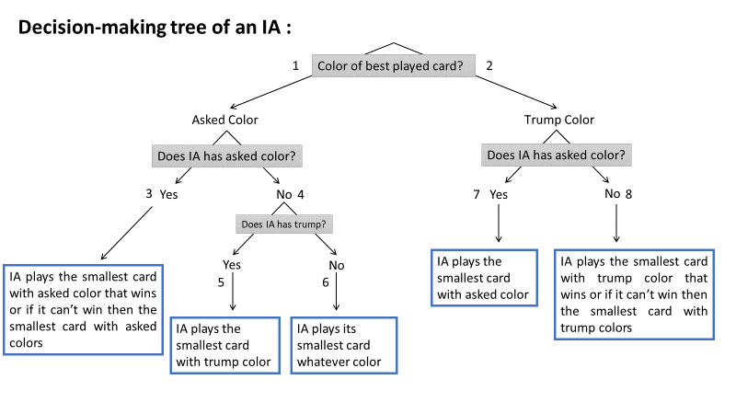
Each question corresponds to a condition. I numbered them to identify them in the program. Each end of branch corresponds to the action that the AI will execute. So this function contains a lot of conditions. The "DetermineTheSmallestCardOfAColor" function is used to determine the smallest card according to a given color and it is also the main element of conditions.
The "GetValueOfACard" function is used when comparing cards. It returns the strength of the card according to the index. It informs the AI that a trump is superior to a simple card.

GameOperations.c
This file

I would like to point out that at the beginning I wrote everything in French, but for the sake of the report I put this part in English anyway.
At the beginning I was lost because it was the first time that I had to make a project like that. In fact, I did not know how to begin the program, which functions. I needed organization. So, I start to search on google « How to start a programming project » and I found the method I needed: a functional analysis. At first, I did not understand what functional analysis was and how I could start with that. What the sites were saying was unclear. But then I realized that I had to break the project down into a multitude of functions.

improvements
These bidding modes are improvements to the game to consider in the future.

